Project 1 – Calculator

Created By: Andrea Chong

Test Case ID: Cal-001

Test Case Description: Test the operator functionality in mathematical calculations

Test Scenario: Verify that the mathematical calculations between Operand 1 and Operand 2 are correct using each of the four operators

Date Tested: 2 Oct 2020

Test Case: Passed

|  |  |
| --- | --- |
| SNo | Test Data |
| 1 | + |
| 2 | - |
| 3 | / |
| 4 | * |
| 5 | = |
| 6 | Operand 1 |
| 7 | Operand 2 |

|  |  |  |  |  |
| --- | --- | --- | --- | --- |
| Step # | Details | Expected Results | Actual Result | Pass/Fail |
| 1 | Run the calculator project via Visual Studio | Calculator should load in browser | As expected | Pass |
| 2 | Enter Operand 1, ‘+’ operator, Operand 2, and ‘=’ | Display should show the answer and the transaction log will record the calculation | As expected | Pass |
| 3 | Enter Operand 1, ‘-’ operator, Operand 2, and ‘=’ | Display should show the answer and the transaction log will record the calculation | As expected | Pass |
| 4 | Enter Operand 1, ‘*’ operator, Operand 2, and ‘=’ | Display should show the answer and the transaction log will record the calculation | As expected | Pass |
| 5 | Enter Operand 1, ‘/’ operator, Operand 2, and ‘=’ | Display should show the answer and the transaction log will record the calculation | As expected | Pass |

Addition

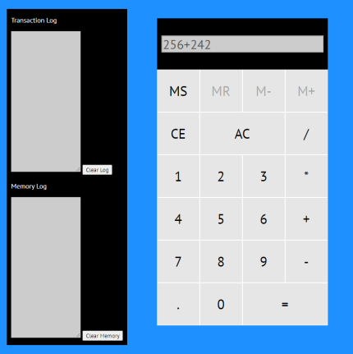 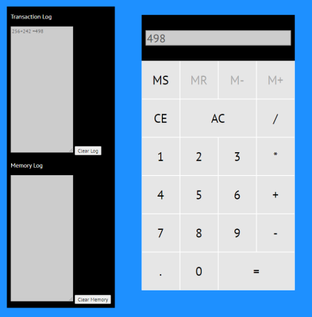

Subtraction

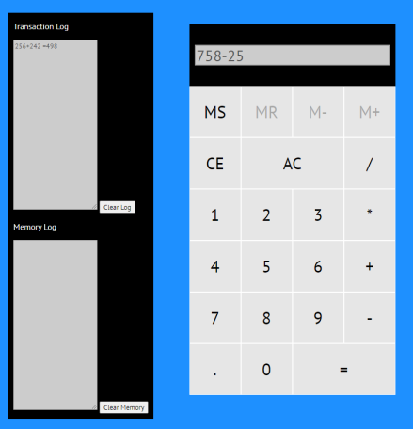 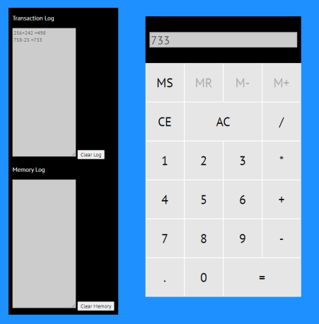

Multiplication

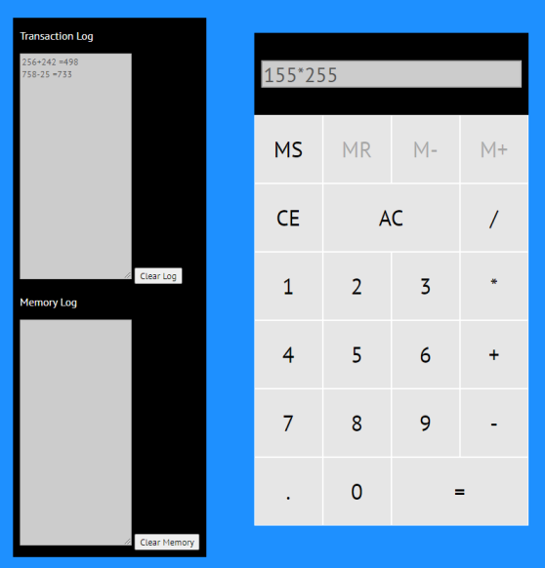 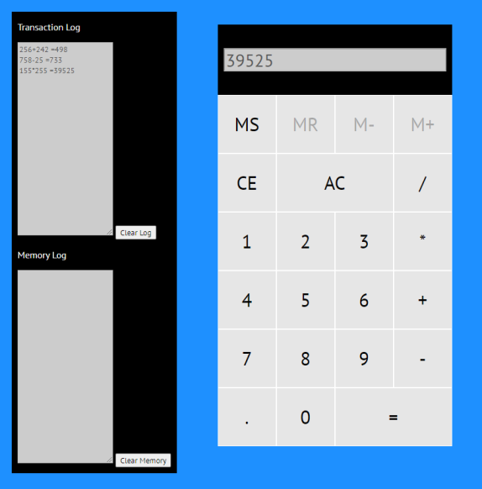

Division

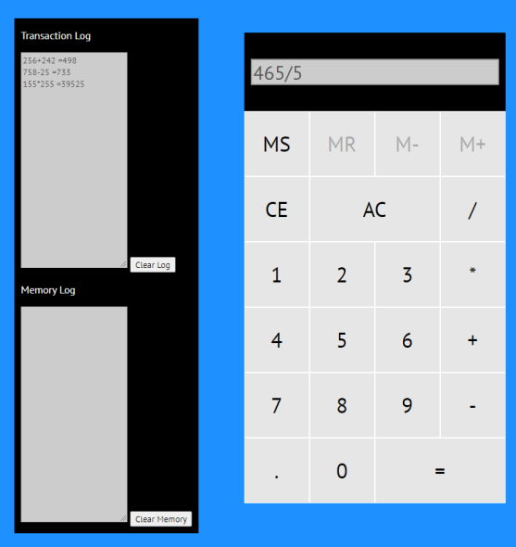 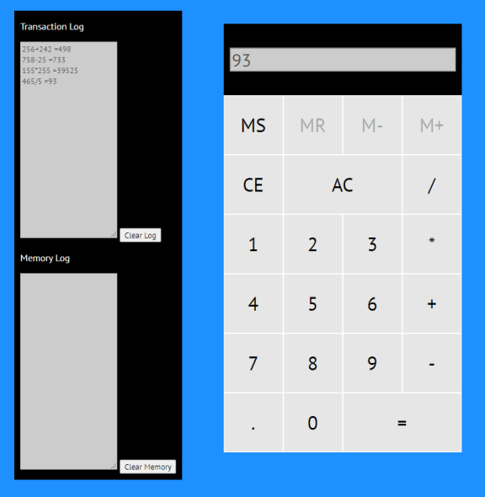

Test Case ID: Cal-002

Test Case Description: Test the error functionality when dividing by ‘0’

Test Scenario: Verify that the calculator is unable to divide the equation by ‘0’ and displays an error message

Date Tested: 2 Oct 2020

Test Case: Passed

|  |  |
| --- | --- |
| SNo | Test Data |
| 1 | Operand 1 |
| 2 | / |
| 3 | 0 |

|  |  |  |  |  |
| --- | --- | --- | --- | --- |
| Step # | Details | Expected Results | Actual Result | Pass/Fail |
| 1 | Run the calculator project via Visual Studio | Calculator should load in browser | As expected | Pass |
| 2 | Enter Operand 1, ‘/’ operator, ‘0’, and ‘=’ | Display should show the error message ‘Error! Cannot divide by zero’ | As expected | Pass |

Division by ‘0’

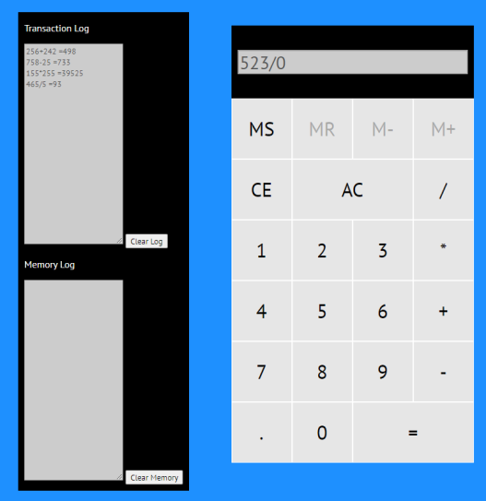 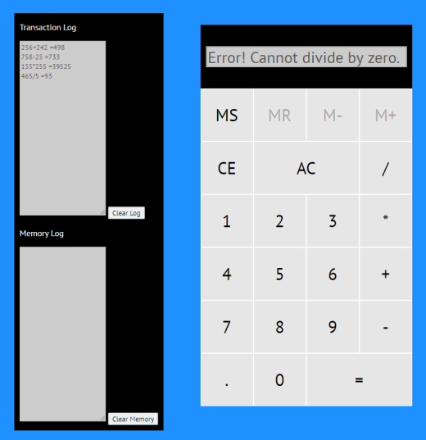

Test Case ID: Cal-003

Test Case Description: Test Memory Store function

Test Scenario: Verify that clicking the memory store activates ‘MR’, ‘M-‘, and ‘M+’ buttons & the number on display is stored in Memory Log.

Date Tested: 2 Oct 2020

Test Case: Passed

|  |  |
| --- | --- |
| SNo | Test Data |
| 1 | Operand 1 |
| 2 | MS button |

|  |  |  |  |  |
| --- | --- | --- | --- | --- |
| Step # | Details | Expected Results | Actual Result | Pass/Fail |
| 1 | Run the calculator project via Visual Studio | Calculator should load in browser | As expected | Pass |
| 2 | Enter an operand | Operand should appear on display | As expected | Pass |
| 3 | Mouse click on ‘MS’ button | The buttons ‘MR’, ‘M-‘, and ‘M+’ should turn black and be clickable, number on display should be in Memory Log | As expected | Pass |

Memory Store

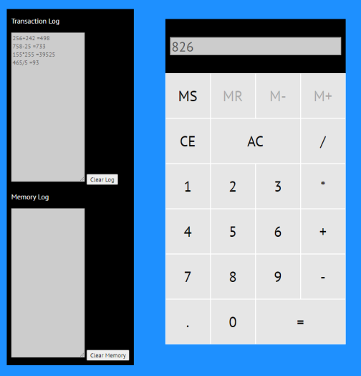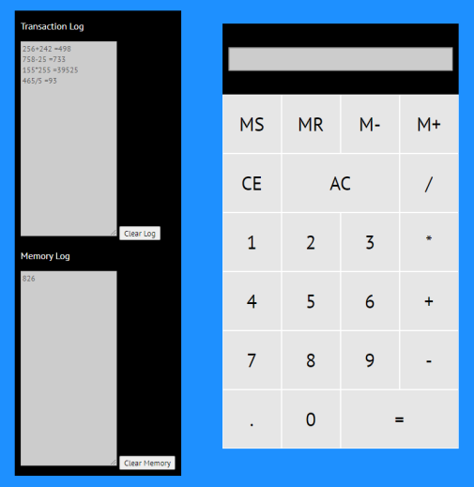

Test Case ID: Cal-004

Test Case Description: Test Memory Repeat function

Test Scenario: Verify that clicking the Memory Repeat button retrieves the top number stored in the Memory Log

Date Tested: 2 Oct 2020

Test Case: Passed

|  |  |
| --- | --- |
| SNo | Test Data |
| 1 | Operand stored in Memory Log |
| 1 | MR button |

|  |  |  |  |  |
| --- | --- | --- | --- | --- |
| Step # | Details | Expected Results | Actual Result | Pass/Fail |
| 1 | Run the calculator project via Visual Studio | Calculator should load in browser | As expected | Pass |
| 2 | Mouse click on ‘MR’ button | The top number stored in the Memory Log is retrieved and displayed on the screen. | As expected | Pass |

Memory Repeat

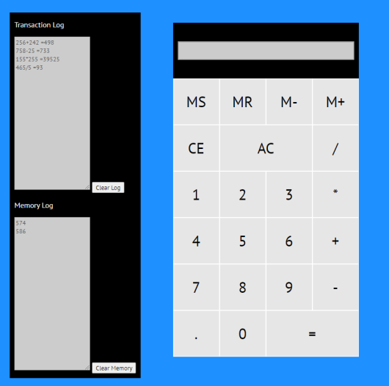 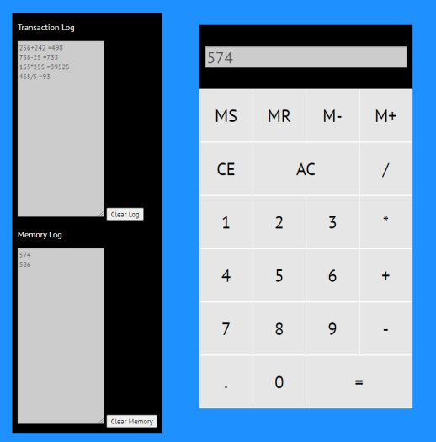

Test Case ID: Cal-005

Test Case Description: Test the Clear function for the calculator, Transaction Log and Memory Log

Test Scenario: Verify that clicking on ‘AC’ or ‘Backspace’ on keyboard clears the display, and clicking on ‘Clear Log’ and ‘Clear Memory’ will clear their respective Logs.

Date Tested: 2 Oct 2020

Test Case: Passed

|  |  |
| --- | --- |
| SNo | Test Data |
| 1 | Operand on Display |
| 2 | ‘AC’ button |
| 3 | Keyboard ‘Backspace’ |
| 4 | ‘Clear Log’ Button |
| 5 | ‘Clear Memory’ Button |

|  |  |  |  |  |
| --- | --- | --- | --- | --- |
| Step # | Details | Expected Results | Actual Result | Pass/Fail |
| 1 | Run the calculator project via Visual Studio | Calculator should load in browser | As expected | Pass |
| 2 | Mouse click on ‘AC’ button or ‘Space’ on keyboard | The input on display should disappear | As expected | Pass |
| 3 | Mouse click on ‘Clear Log’ button | The transaction log should clear and be empty | As expected | Pass |
| 4 | Mouse click on ‘Clear Memory’ button | The memory log should clear and be empty, ‘MR’, ‘M+’ and ‘M-‘ buttons should be deactivated | As expected | Pass |

Clear functions

